Arduino Lesson 5
Traffic Light
- Intro
- This experiment actually is an extend version of lesson 2.
- We can use lesson 2 for reference, use digital interface # 10、#7、#4.
- Use Arduino delay（）function to control the delay time.
- Parts required
Besides Arduino main board and USB cable, we also need
Red 5mm LED x 1
Yellow 5mm LED x 1
Green 5mm LED x 1
220ΩResistor x 3
Breadboad x 1
Jumper wires x 1 Bundle
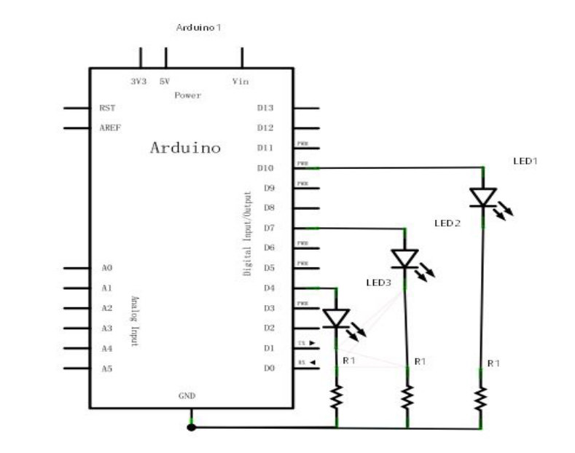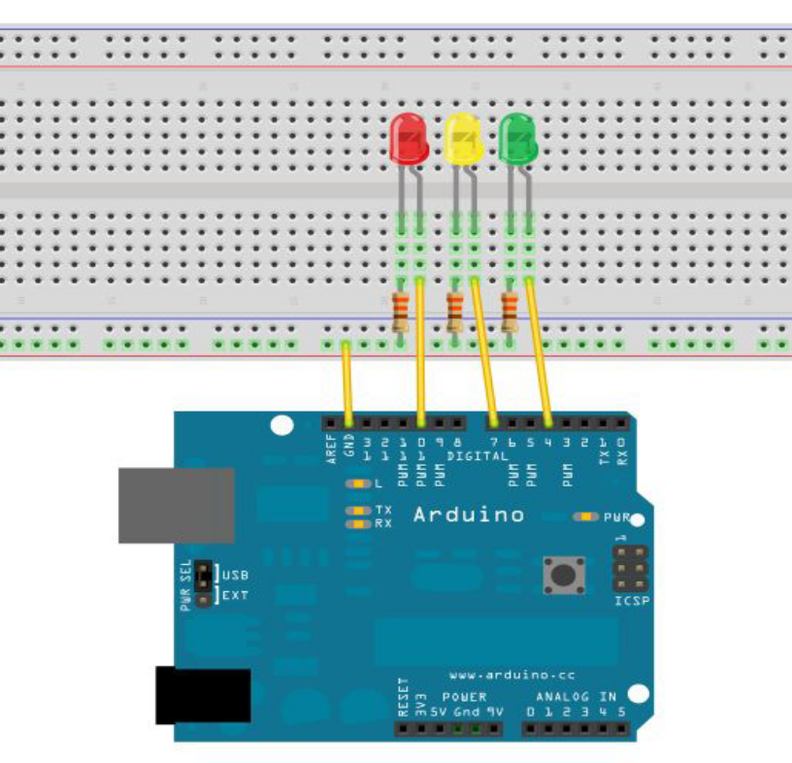

- Program for reference
int redled =10; // Define digital interface #10.
int yellowled =7; // Define digital interface #7.
int greenled =4; // Define digital interface #4.
void setup()
{
pinMode(redled, OUTPUT);// Define red LED interface as output.
pinMode(yellowled, OUTPUT); // Define yellow LED interface as output.pinMode(greenled, OUTPUT); // Define green LED interface as output.
}
void loop()
{
digitalWrite(redled, HIGH);// Turn on red led.
delay(1000);//Delay 1 sec
digitalWrite(redled, LOW); // Turn off red led.
digitalWrite(yellowled, HIGH);// Turn on yellow led.
delay(200);//Delay 0.2 sec
digitalWrite(yellowled, LOW);//Turn off yellow led.
digitalWrite(greenled, HIGH);// Turn on the green led.
delay(1000);//Dealy 1 sec.
digitalWrite(greenled, LOW);//Turn off green led.
}
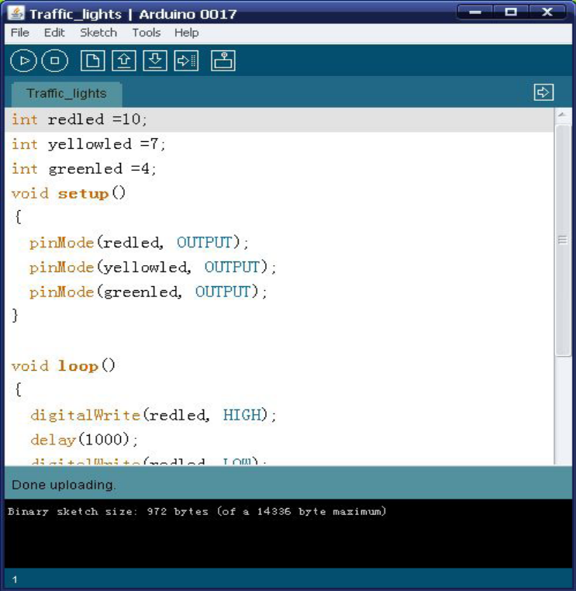
Download the program you will see the traffic light is working.

